企业介绍
ZEHO WATERFRONT INTRODUCTION

公司简介/About Us
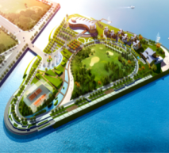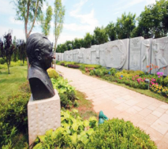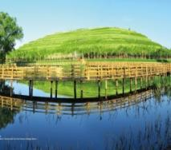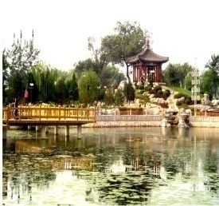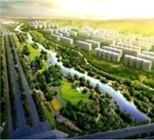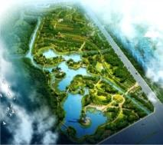
北京正和恒基滨水生态环境治理股份有限公司成立于1997年，注册资本9000万股，注册在北京市海淀区中关村环保园（国家高新技术企业），是一家以滨水园林为主业，集滨水区域生态环境治理前沿技术研发、滨水区域商业策划运营，城市规划、景观设计、生态景观营建为一体的城市生态环境治理综合环境服务提供商。
Beijing ZEHO Waterfront Ecological Environment Treatment Corp.，established in 1997, with a registered capital of 90 million, registered in ZhongGuanCun Environmental Protection Park in Beijing Haidian District（is the national high and new technology enterprise），operates an integrated business system including the research, development, planning, design, and construction of waterfront landscape architecture. ZEHO’s core businesses include: waterfront ecology research, urban planning and design, business planning of urban waterfronts, construction of waterfront architecture, restoration of waterfront environments, and landscape architecture.
公司下设滨水生态技术研究院、城市规划景观设计院2家专业机构，在北京、河北、山西、山东、天津、上海设有区域公司，积极倡导科研、设计、施工一体化，为城市滨水生态环境治理提供集成服务。公司通过对滨水生态的规划设计和滨水景观的营建，在创建美好人居环境的同时，促进滨水区域经济的快速发展。
ZEHO’s two subsidiaries, the Eco-Waterfront Technology Research Institute and Urban Planning & Design Co., Ltd., with six regional companies in Beijing, Hebei, Shanxi, Shandong, Tianjin, Shanghai, and its self-owned engineering division, ensure clients benefit directly from our technological innovation and engineering expertise. ZEHO is dedicated to solving problems affecting today’s urban waterfront. Advanced technology, first-rate design and consistency of delivery have forged ZEHO into a builder of waterfront landscape and an engine developing waterfront areas.
公司具有风景园林设计甲级、城市园林绿化壹级“双甲”资质，及城乡规划编制乙级、河湖整治工程专业承包三级资质，为国家“高新技术企业”，“全国园林景观工程质量、安全、信誉AAA级优秀放心施工单位”，并通过ISO国际管理体系质量、环境、职业健康标准认定。
ZEHO holds first grade national qualification certificates in design and construction of landscape architecture. ZEHO is authorized by the State as 3rd class enterprise to undertake river and lake project. The company passed ISO Certification. And, as recognition of our scientific innovation, the company was officially recognized as a national high-tech enterprise in 2011.
十几年来，公司励精图治、努力拼搏，市场业务不断扩大，北戴河奥林匹克大道公园、北京世妇会水上公园、迁安黄台湖景观、唐山青龙湖公园、曹妃甸行政接待中心、迁西滦水湾公园等多个项目荣获国家级金奖。
Over a decade, ZEHO owes its success and reputation to its many high profile projects, such as the River Luan Park, the Beijing World Conference on Women Memorial Park, and the Tangshan Round-city Waterway System.
公司2012年营业收入为4.5亿元，净利润6750万元，2013年收入超过6亿元，净利润超过9000万元，2014年预计收入9亿元，预计净利润达到1.4亿元，公司未来将保持年均30%-50%的收入和利润增长速度。
In 2012, ZEHO’s annual income was 450 million, and the net profit was 67.5 million. In 2013, the company`s annual income has been over 600 million and the net profit has been more than 90 million. In 2014, the expected annual income is to be 900 million, and the expected net income will be 140 million. In the future, the company will maintain an annual 30% - 50% increase of the revenue and profit growth.
公司以2011年11月30日为基准日完成了股份制改造，计划2014年上半年上报上市申请材料，2015年之前完成企业IPO上市，企业的目标是打造滨水生态环境治理的第一品牌。
ZEHO has completed the shareholding system reform with the base date in November 30, 2011. ZEHO has plan to report the application materials in the first half of 2014, to complete IPO before 2015. ZEHO’s goal is to create the first brand of the Waterfront Ecological Environment Treatment.

业务介绍/Business Introduction
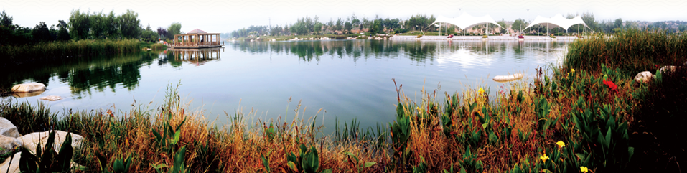
- 主营业务/ ZEHO’s Core Businesses Include：
公司以滨水园林为主业，提供滨水区域生态环境治理前沿技术研发、滨水区域商业策划运营，城市规划、景观设计、生态景观营建为一体的城市生态环境治理综合环境服务。公司以提升城市形象、推动城市滨水经济发展为宗旨，积极倡导科研、设计、施工一体化运营，塑造中国滨水生态环境治理行业第一品牌。
ZEHO’s core businesses include: waterfront ecology research, urban planning and design, commercial waterfront planning, construction of waterfront architecture, restoration of water environment, and landscape architecture.
ZEHO is dedicated to solving problems of today’s urban waterfront through research, design and construction. We offer our clients an integrated “one-stop solution.” Through improving China’s urban landscape and stimulating the local economies, ZEHO aims to become the premiere waterfront landscape company in China.

- 业务模式/ ZEHO’s Business Model：
- 模式一：金融合作模式
研究国家生态文明政策和政府需求，设计新商业模式，推进金融+政府+企业的合作模式，主动创造项目机会；
Model 1: the Financial Cooperation Pattern.
To research the national policy of ecological civilization and government requirements, to design the new business model, to promote the cooperation pattern of “Finance + Government + Enterprise, and to take the initiative to create project opportunities.
- 模式二：国家投资项目模式
开拓生态修复、生态湿地的国家投资项目，关注园博会、运动会举办城市，抓住创建国家园林城市、水生态文明试点城市等市场机会；对其中重点项目进行突破。
Model 2: National Investment Project Pattern.
Explore the national investment projects of ecological restoration, ecological wetland, focus on the host cities for garden expo & the games, seize the market opportunities such as national garden city, water ecological civilization pilot city, etc., and focus on some key projects in breakthrough.
- 模式三：地方政府新城项目模式
开拓地方政府重点打造的新城新区项目，要求项目过程付款达到40%以上，并且后期工程款能够得到保障的项目（土地出让金或其它保障）。
Mode 3: New Town Project Model of Local Government.
Develop the new town projects of local government viewed as the major, with the request of a process payment of 40% or more, and the ensured late payment(land-transferring fees or other securities).
- 模式四：县域经济模式
开拓经济发达，人口较多县域市场，要求承接当地政府重点一号工程，过程付款达到60%以上，能够与金融和地产开发结合的项目。
Mode 4: County Economy Pattern.
Expand the county market with developed economy and more populous, required to undertake the No.1 project from local government, with the process payment of 60% or more, combined with the financial and real estate development projects.
- 模式五：房地产园林项目模式
开拓全国地产50强的品牌地产、旅游地产的景观绿化项目。
Mode 5: Real Estate Landscape Pattern.
Develops the landscape greening projects from the national top 50 of real estate enterprises, or the tourism real estate enterprises.

企业优势/ Enterprise Advantages
核心技术——tRDC一体化解决体系
Core Technology——Integration Solutions System of Trinity of Research, Design & Construction
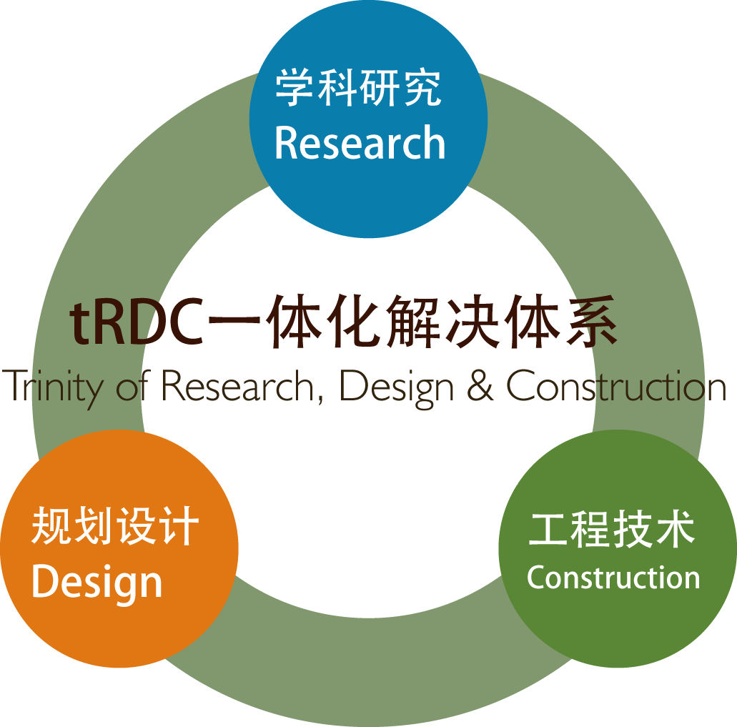
科研设计施工一体化/ Trinity of Research, Design & Construction
tRDC是公司经过多年实践经验积累，自主总结完善的一套科学的综合治理“城市滨水环境”的操作体系。其中包括优化整合的项目操作流程和全面的滨水核心治理技术。该体系将“研发、设计、施工”有效融为一体，强调项目中水务科学功能性与自然生态的结合，强调滨水环境的地域特色及可持续性。
Extensive engineering experience has enabled ZEHO to develop its own solution to address the challenge of modernizing China’s urban waterfront. We call this our trinity of research, design & construction (tRDC). The system is an all-in-one solution including streamlined project management and comprehensive waterfront treatment technology. The system integrates cutting edge research, design and construction. We focus on water management, creating a local identity, and sustainability.
近年来公司综合运用tRDC一体化解决体系，为城市河道综合规划、湿地公园、盐碱地绿化、沉砂池规划、河道生态恢复和众多滨水相关项目园林景观进行专项研究设计，打造科学、生态、系统的滨水园林景观。
In recent years, ZEHO applied tRDC to a number of projects including waterway planning, wetland parks, saline and alkali land greening, sediment basin, waterway rehabilitation, and other waterfront projects. With its systematic approach, ZEHO is committed to building scientifically and ecologically sound waterfront landscape projects to help improve the image and environment of Chinese cities.

企业荣誉/Honors
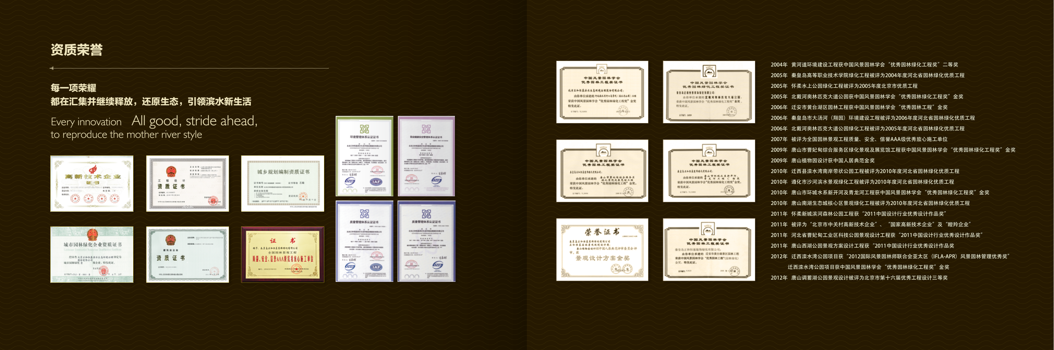
我公司一直致力于滨水生态环境治理，注重滨水生态技术与景观设计、工程的结合。近年来，承建项目获得多项荣誉。
ZEHO has been improving China's urban waterfront environment for years. This relies heavily on technological competence to solve problems, at the same time as combining a high level of designing and building skill. Many of its finished projects have been recognised at national and provincial levels and are now landmark sites in Chinese cities.
奖项/the honors：
2004年 黄河道环境建设工程获中国风景园林学会“优秀园林绿化工程奖”二等奖
2005年 秦皇岛高等职业技术学院绿化工程被评为2004年度河北省园林绿化优质工程
2005年 怀柔水上公园绿化工程被评为2005年度北京市优质工程
2005年 北戴河奥林匹克大道公园获中国风景园林学会“优秀园林绿化工程奖”金奖
2006年 迁安市黄台湖区园林工程获中国风景园林学会“优秀园林工程”金奖
2006年 秦皇岛市大汤河（翔园）环境建设工程被评为2006年度河北省园林绿化优质工程
2006年 北戴河奥林匹克大道公园绿化工程被评为2005年度河北省园林绿化优质工程
2007年 被评为全国园林景观工程质量、安全、信誉AAA级优秀放心施工单位
2009年 唐山市曹妃甸综合服务区绿化景观及展览馆工程获中国风景园林学会“优秀园林绿化工程奖”金奖
2009年 唐山植物园设计获中国人居典范金奖
2010年 迁西县滦水湾南岸带状公园工程被评为2010年度河北省园林绿化优质工程
2010年 遵化市沙河滨水景观绿化工程被评为2010年度河北省园林绿化优质工程
2010年 唐山市环城水系新开河及青龙河工程获中国风景园林学会“优秀园林绿化工程奖”金奖
2010年 唐山南湖生态城核心区景观绿化工程被评为2010年度河北省园林绿化优质工程
2011年 怀柔新城滨河森林公园工程获“2011中国设计行业优秀设计作品奖”
2011年 被评为“北京市中关村高新技术企业”、“国家高新技术企业”及“瞪羚企业”
2011年 河北省曹妃甸工业区科技公园景观设计工程获“2011中国设计行业优秀设计作品奖”
2011年 唐山西湖公园景观方案设计工程获“2011中国设计行业优秀设计作品奖
2012年 迁西滦水湾公园项目获“2012国际风景园林师联合会亚太区（IFLA-APR）风景园林管理优秀奖”
迁西滦水湾公园项目获中国风景园林学会“优秀园林绿化工程奖”金奖
2012年 唐山调蓄湖公园景观设计被评为北京市第十六届优秀工程设计三等奖

2012 IFLA-APR Merit Award, River Luan Rehabilitation Project, Qian’an City
2011 China Good Design Award, Tangshan Qinglong Lake
2011 China Good Design Award, Huairou Waterfront Forest Park
2011 China Good Design Award, Caofeidian Industrial Park Tech Garden
2010 Hebei Province Top Award, Quality Landscape Architecture, Luanhe River Project
2009 Human Habitat National Top Honor Award, Tangshan City Botanic Garden
2006 The company won recognition as a National Quality, Safety, and Credit AAA Level “Trustworthy Contractor”
2006 Hebei Province Top Award, Quality Landscape Architecture, Xiang Park in Qinhuangdao City
2005 Beijing Municipal Award, Quality Project, Huairou World Women Conference Memorial Park
2004 Chinese Society of Landscape Architecture (CHSLA) National 2nd Award, Quality Landscape Architecture, Yellow River Riverway.

企业愿景/Company Vision

与城市河流一起成长 创造美好人居环境
Grow with urban rivers Create a better world

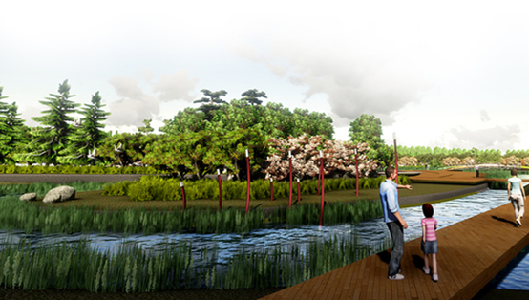

企业理念/Company Values
“大道源和 诚信永恒”
Harmony Makes Superiority; Integrity Generates Eternity
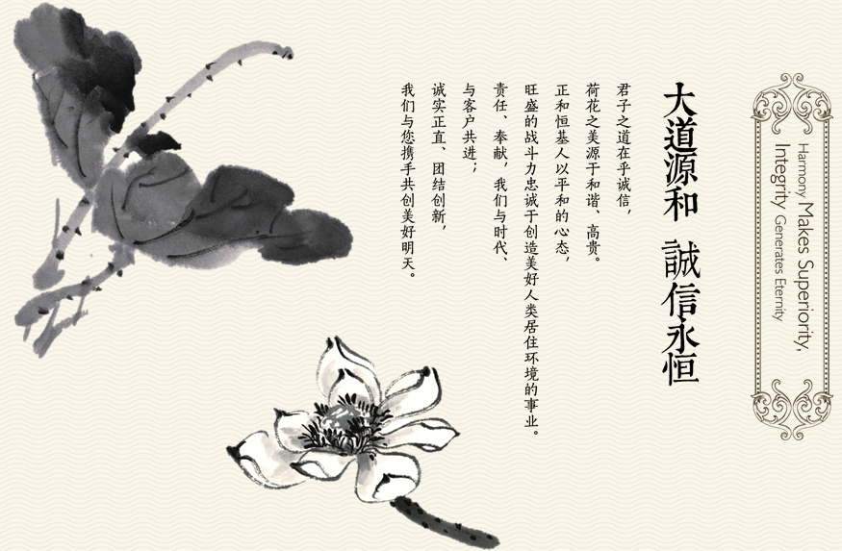

联系我们/Contact Us
北京正和恒基滨水生态环境治理股份有限公司
Beijing ZEHO Waterfront Ecological Environment Treatment Corp.
总机/Tel: 010-59847988/59847999
传真/Fax: 010-82601974
地址/Add: 北京市海淀区中关村东路1号清华科技园科技大厦B座21层/27层
21&27/F, Tower B, Science & Technology Bld., THU Science Park, No.1 Zhongguancun East Road, Haidian District, Beijing, China
网址/Web: http://www.zeho.com.cn
邮箱/Mail：hr@zeho.com.cn

