Automotive
- Volkswagen AG, Wolfsburg
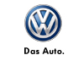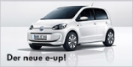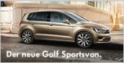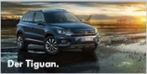
„The Volkswagen Group with its headquarters in Wolfsburg is one of the world’s leading automobile manufacturers and the largest carmaker in Europe. In Western Europe, almost one in four new cars (24.4 percent) is made by the Volkswagen Group.
The Group comprises twelve brands from seven European countries: Volkswagen Passenger Cars, Audi, SEAT, ŠKODA, Bentley, Bugatti, Lamborghini, Porsche, Ducati, Volkswagen Commercial Vehicles, Scania and MAN.
The Group operates 106* production plants in 19 European countries and a further eight countries in the Americas, Asia and Africa. Every weekday, 570,000** employees worldwide produce some 37,700 vehicles, and work in vehicle-related services or other fields of business. The Volkswagen Group sells its vehicles in 153 countries.
The Group’s goal is to offer attractive, safe and environmentally sound vehicles which can compete in an increasingly tough market and set world standards in their respective class.“

- Continental Automotive GmbH, Hannover
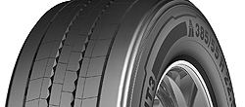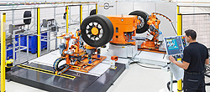
„Automotive Group: With provisional sales of around €33.3 billion in 2013, Continental is among the leading automotive suppliers worldwide. As a supplier of brake systems, systems and components for powertrains and chassis, instrumentation, infotainment solutions, vehicle electronics, tires, and technical elastomers, Continental contributes to enhanced driving safety and global climate protection. Continental is also an expert partner in networked automobile communication.
Continental was founded in Hanover in 1871 as the stock corporation “Continental-Caoutchouc- und Gutta-Percha Compagnie”. Manufacturing at the main factory in Hanover included soft rubber products, rubberized fabrics, and solid tires for carriages and bicycles.
With around 170,000 employees (Status: December 31, 2012) in 46 countries, the Continental Corporation is divided into the Automotive Group and the Rubber Group, and consists of five divisions: Chassis & Safety, Powertrain, Interior, Tires, ContiTech.“

- Robert Bosch GmbH, Hildesheim
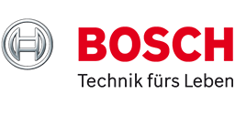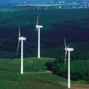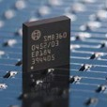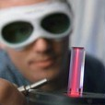
“The Bosch Group is a leading global supplier of technology and services. In 2012, its roughly 306,000 associates generated sales of 52.5 billion euros.
Since the beginning of 2013, its operations have been divided into four business sectors: Automotive Technology, Industrial Technology, Consumer Goods, and Energy and Building Technology.
The Bosch Group comprises Robert Bosch GmbH and its roughly 360 subsidiaries and regional companies in some 50 countries. If its sales and service partners are included, then Bosch is represented in roughly 150 countries.
The company was set up in Stuttgart in 1886 by Robert Bosch (1861–1942) as “Workshop for Precision Mechanics and Electrical Engineering.” The special ownership structure of Robert Bosch GmbH guarantees the entrepreneurial freedom of the Bosch Group, making it possible for the company to plan over the long term and to undertake significant upfront investments in the safeguarding of its future.”

- Johnson Controls Inc. Hannover
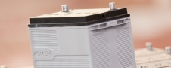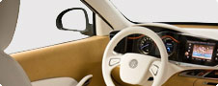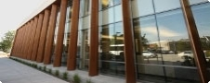
„Johnson Controls is a global diversified technology and industrial leader serving customers in more than 150 countries.
Our 170,000 employees create quality products, services and solutions to optimize energy and operational efficiencies of buildings; lead-acid automotive batteries and advanced batteries for hybrid and electric vehicles; and interior systems for automobiles.
Our commitment to sustainability dates back to our roots in 1885, with the invention of the first electric room thermostat.
Through our growth strategies and by increasing market share we are committed to delivering value to shareholders and making our customers successful.“

Information Technology
- TUI Info TEC GmbH, Hannover
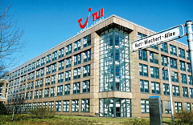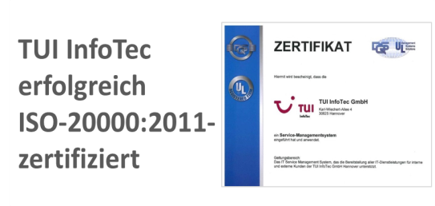
„TUI Info TEC GmbH was founded in 1997 as an independent company in the field of information systems of the TUI. Together with the changes and acquisitions of the Hanoverian travel provider the IT service provider was continuously growing with increasingly international and sector unspecific orientation.
Today TUI InfoTEC as a 100% stake of TUI Travel PLC is working for the global TUI Group. About 700 companies – from travel agencies to tour operators and airlines to hotel companies – belong to the global TUI-Company. TUI Info TEC is also working for customers outside of the TUI Group.
Facts and figures:
Headquarter: Hannover | Number of employees: 320 (as of 2013)
Form of enterprise: GmbH | Services: cloud services, application management, ERP system development, process consulting and operations, infrastructure services
Shareholders: TUI Travel PLC (100%) | Subsidiary travel-BA.Sys, ACCON-RVS
“
- HaCon Ingenieurgesellschaft mbH, Hannover
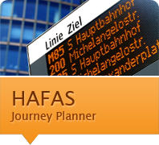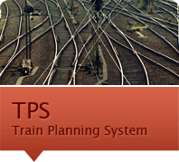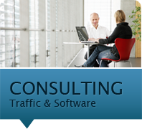
„Headquartered in Hannover, Germany, HaCon creates and develops high-quality software solutions for traffic, transport and logistics. With 30 years of experience and a dedicated team of 200 IT and transport planning specialists, HaCon has established itself as a leading European player for planning, scheduling and information solutions.
The timetable information system HAFAS is used by transportation companies and networks all over the world. Every day, passengers in 25 countries place over 40 million journey planner requests that facilitate the use of public transport. Long-time HAFAS customers such as Deutsche Bahn (Germany) and SNCF (France) benefit from ever new, innovative developments for mobile applications, internet journey planners and printed timetables.“
- Sartorius AG, Göttingen
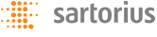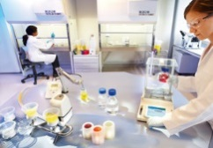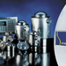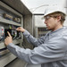
„Sartorius is one of the world's leading providers of laboratory and process technologies and equipment. Our innovative products and high-quality services help customers around the globe implement complex and quality-critical processes in biopharmaceutical production and laboratory environments in a time- and cost-efficient way. Our key customers are from the biotech, pharma and food industries, as well as from public research institutes and laboratories. Sartorius operates its own production facilities in Europe, Asia and America, and also has sales offices and local representatives in more than 110 countries. Strongly rooted in the scientific and research communities and closely allied with customers and technology partners, the company is dedicated to its philosophy of "Turning science into solutions" every single day.
Sartorius operates as a global player in dynamic markets around the world. Yet the Group has retained much of its home-grown identity – strong regional ties and a personal corporate culture that has remained strongly intact since the company’s origins as a family business. Today, more than 5,500 people work together at Sartorius worldwide. They hail from a diversity of cultures with different traditions, work styles and languages. What unites all employees at Sartorius is their strong identification with the company and the common vision, mutual goals and strategies and a common set of values they all share: Sustainability, Openness and Enjoyment.“

Agricultural sector
- Big Dutchman, Vechta
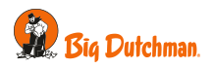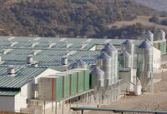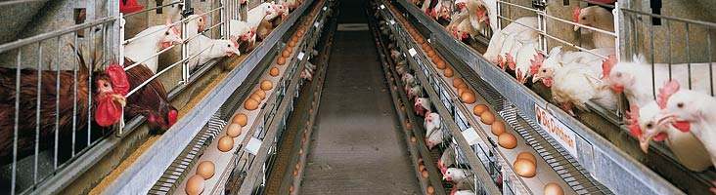
„The birth of our company dates back to 1938. In that year, the brothers Richard and Jack DeWitt, whose parents emigrated from the Netherlands to the US, invented a sophisticated machine for automatic feeding of their poultry stock. The feeder transported feed via a mechanically driven chain. It was to become the world's first automatic feeding system! To supply the rapidly growing demand for these feeders, the two brothers set up a division which was devoted exclusively to automatic installations for poultry management. They named the new enterprise "Big Dutchman" - reflecting their pride in their Dutch ancestry.
In the late 1950s, a subsidiary company was established in the Netherlands. The business flourished and in 1958, Big Dutchman decided to engage a sales representative in Germany. They selected a 26-year-old poultry farmer from Calveslage in Lower Saxony. Today the company is acting in two fields: poultry and pig production.“

- Grimme Landmaschinenfabrik GmbH & Co. KG, Damme

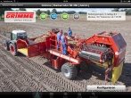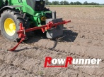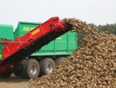

„70 years ago developed the father of today's owner Mr. Franz Grimme the first potato harvesters. That was the beginning of the Grimme Landmaschinenfabrik in Damme. In the course of the years, the company developed into the complete supplier for potato, beet and vegetable technology. The well-known red machines work in over 110 countries worldwide. Own sales and service agencies in Belgium, China, Denmark, England, France, Ireland, the Netherlands, Poland, Russia, Turkey and U.S.A. look after the customers in these countries.
The Grimme machines are produced at two high modern manufacturing locations. All machines except self-propelled harvesters build in the headquarter in Damme. The ultramodern logistic center is based on a fully automated high-bay warehouse-system, which supplies the assembly with all the required parts "just-in-time". On an area of 15 ha there is also a research and development department, the enterprise administration and an own training center located. Over 1,300 employees work in plant 1 and 2. The company trains over 124 young people in various technical and commercial professions. “

- Kotte Landtechnik GmbH & Co. KG, Rieste

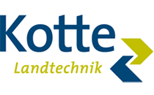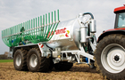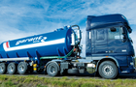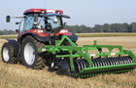
„Kotte Landtechnik was founded in 1892. Today the company is controlled by the 4th generation as a family enterprise. With the brand name GARANT Kotte manufactures in addition to latest slurry technology soil cultivation machinery and transport technology, too.
Further lines of business are the trade with Case IH tractors as well as machinery for soil cultivation and sowing from Maschio.

The Kotte Landtechnik GmbH & Co. KG is based in Rieste/Lower Saxony (district Osnabrück). Development and manufacture of the machinery takes place at two places in Rieste with latest manufacturing facilities. That way the high product quality is made sure. Furthermore Kotte company has a well organized dealer network, where the customers are serviced optimal.“

- Agrarfrost GmbH & Co. KG, Wildeshausen / Aldrup
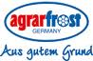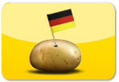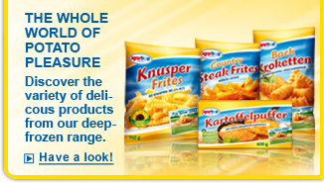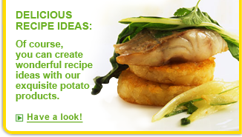
„Discover variety: many areas, one know-how!
In addition to the top-class frozen potato specialties enjoyed by millions of gourmets at home and professionals in the catering trade, our potatoes also have an excellent reputation in the food industry and in the trade: for example our potato flakes for further processing or the irresistible potato snacks such as our crunchy crisps. As you can see, Agrarfrost is as surprising and versatile as our raw material, the potato! Whether in the family, the restaurant or elsewhere, we are always loved - and for good reason.
With our more than 600 employees in two locations, we are an expanding mid-sized company that operates in the food industry throughout Europe. We are known as an innovative, flexible company with an extensive, high-quality range of frozen potato products.“

- Wiesenhof Geflügel-Kontor GmbH, Visbek
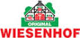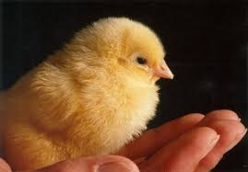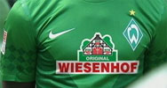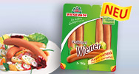

„In three generations, from a small country store to Germany's poultry trade mark No 1 - it was a long , exciting , exciting and successful way for WIESENHOF. And one way, which is not far from over. Running a business successfully in the globalized world of the 21st To lead the century, this is the task facing us today.
Issues such as quality, safety and sustainability are becoming more and more important. How do you manage to produce in a market that already covers the entire world foods that meet all the requirements? Retailers, consumers, employees, and of course our poultry, they all have interests that we have considered.
WIESENHOF developed concepts which are always groundbreaking. Already in 1995 we established the first poultry suppliers of origin guarantee and waived already on meat and bone meal before ever started the discussions on that. The development of innovative poultry dishes characterize WIESENHOF. Since time immemorial, there can WIESENHOF of the slogan " We do more " guide and has made ​​us what we are today: German poultry brand No. 1.“

- Maschinenfabrik Bernard Krone GmbH, Spelle
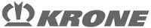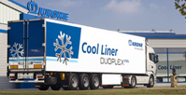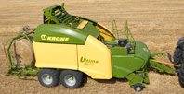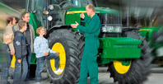
“Krone is a leading global manufacturer in the Commercial Trailers and the Agricultural Machinery divisions.
Family-owned for the fourth generation, we are conscious of our responsibility towards the future generations and for us environmental protection is not merely a lip service. Already for years, we at KRONE have paid attention to sustainability in production of trailers and therefore develop futuristic products, establishing new yardsticks in ecology and economy domain. When it comes to production of vehicles, sustainability remains very much in focus. We consider it our primary duty and responsibility to push forward innovations even about the environment. We promote the use of renewable energy sources and reduction in CO2 emissions.”

CFK Lightweight construction
- Airbus S.A.S., Hamburg
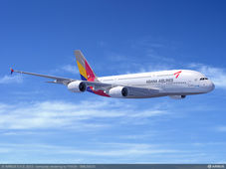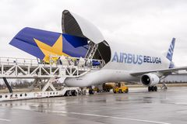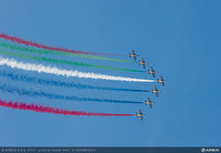
Airbus is the world’s leading commercial aircraft manufacturer whose customer focus, commercial know-how, technological leadership and manufacturing efficiency have propelled it to the forefront of the industry.
Airbus’ modern and comprehensive product line comprises highly successful families of aircraft ranging from 100 to more than 500 seats: the single-aisle A320 Family, including the A320neo product line, which is the fastest-selling aircraft in aviation history – the widebody, long-range A330/A340, all-new next generation A350 XWB Family and the double-deck A380 Family. The company also continues to broaden its scope and product range by applying its expertise to the military market. It is as well extending its portfolio of freighter aircraft that will set new standards in the general and express freight market sectors.
Across all its fly-by-wire aircraft families Airbus’ unique approach ensures that aircraft share the highest possible degree of commonality in airframes, on-board systems, cockpits and handling characteristics, which reduces significantly operating costs for airlines. Dedicated to helping airlines enhance the profitability of their fleets, Airbus also delivers a wide range of customer services in all areas of support, tailored to the needs of individual operators all over the world.
- Continental AG, Hannover
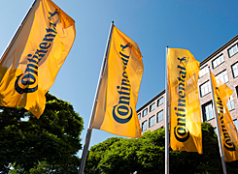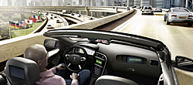
“Timeline: 1871: Continental Caoutchouc- und Gutta-Percha Compagnie is founded in Hanover as a joint stock company. Manufacturing at the main factory includes soft rubber products, rubberized fabrics, solid tires for carriages and bicycles. 1952: Continental adds M+S tires for winter driving to its range of conventional tires. 1971: Europe's largest hose manufacturing facilities are set up at the Korbach plant. The entire hose production is transferred from Hanover to Korbach. 1998: Acquisition of a US company's Automotive Brake and Chassis unit, the core of which is Alfred Teves GmbH in Frankfurt. 2011: To mark the occasion of Continental's anniversary on October 8th, diverse individual celebrations took place at many of the more than 190 Continental locations around the world.
Today, Continental ranks among the top 5 automotive suppliers worldwide. As a supplier of brake systems, systems and components for powertrains and chassis, instrumentation, infotainment solutions, vehicle electronics, tires and technical elastomers, Continental contributes to enhanced driving safety and global climate protection. Continental is also a competent partner in networked automobile communication.”
- Salzgitter AG, Salzgitter
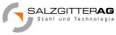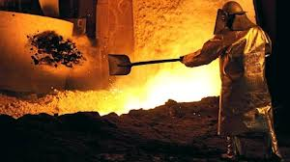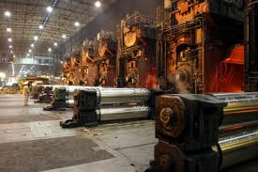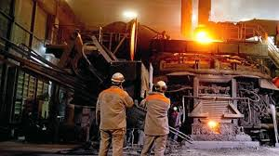
“Salzgitter AG ranks among the leading steel technology groups with around € 10 billion in external sales, a crude steel capacity of almost 9 million tons and a workforce of 25,000 employees. It is one of Europe's largest steel producers and the global market leader in the large-diameter pipes business. The Group operates cutting-edge and resource-efficient production sites in Germany and abroad. It consists of more than 200 subsidiary and holding companies and, headed by Salzgitter AG, is structured as a holding comprising the five business units of Strip Steel, Plate/Section Steel, Trading, Energy and Technology.
The product portfolio includes a wide variety of strip steel products, beams, heavy plate, as well as seamless and welded tubes in all dimensions. Furthermore, Salzgitter AG manufactures processed products for the automotive and construction industries. The Technology Business Unit comprises several specialist machine construction companies, including one of the world's leading manufacturers of filling and packaging plants for the beverages, food and non-food industry.
The share of Salzgitter AG is listed on the MDAX index of Deutsche Börse AG.”
Medical technology
• Otto Bock Health Care GmbH, Duderstadt
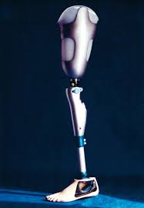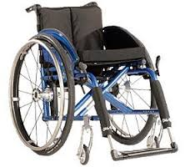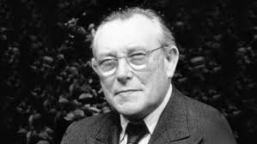
“All around the world, the Ottobock name stands for high-quality, technologically outstanding products and services. The goal of helping people by restoring their mobility and preserving remaining functions stands behind each and every Ottobock product. The conviction that quality of life is intimately linked to maximum independence has been a strong influence throughout the company’s 90 year history.
The Otto Bock group of companies consists of Otto Bock HealthCare (medical technology), Otto Bock Kunststoff and Technogel (chemistry), and Sycor (information and communication technology).
The third-generation, family-run business is firmly supported by these three pillars in the most important global growth markets.”

• KIND Hörgeräte GmbH & Co. KG, Großburgwedel/Hannover
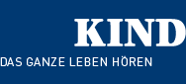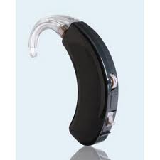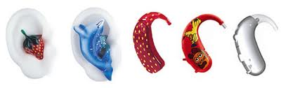
„KIND is the leading family company of the hearing aid technology. With over 600 stores and over 2,400 employees KIND is one of the world's most successful and fastest growing companies in its sector. Its high quality standards developed KIND in close cooperation with experienced ear, nose and throat doctors and health insurance continuously.
Specific responsibility KIND has as the largest trainer of the hearing aid. The company's employees are among the most qualified in the industry.
audifon, a member of the KIND group also develops and produces modern and powerful hearing aids in Kölleda / Thuringia. The worldwide distribution of its products through its own sales companies and distribution partners goes in over 65 countries.“

- Deutsches Hörzentrum Hannover
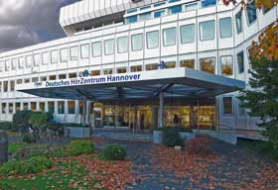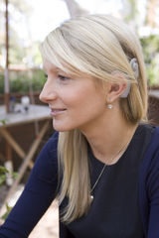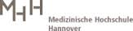

“Founded in 2003 German Hörzentrum Hanover (DHZ) the ENT Clinic of the MHH offers the complete service: from comprehensive audiological differential diagnosis, on the advice of a possible hearing, if necessary, an operation through to lifelong medical, technical and pedagogical follow-up and care of patients. Closely interlocked, a team is working here with Prof. Dr. med Thomas Lenarz: ENT physicians, medical engineers, educators and speech therapists, hearing care, manufacturer of hearing systems as well as scientists to the development of medical devices in direct communication with the patient.
The German Hörzentrum Hanover advises his patients over the complete range of current hearing instruments: conventional hearing aids, middle ear implants, cochlear implants and tinnitus Noiser. Hearing systems as the ABI (auditory brainstem implant) are offered and developed in Hannover AMI (auditory midbrain implant) for so-called NF2 patients (neurofibromatosis type 2) was implanted in the ENT Clinic of the MHH worldwide for the first time.
Internationally known is the ENT Clinic and the DHZ for the world's largest cochlear implant program. By 2008, more than 4,000 adults and children could be implanted. Approximately 500 patients are newly furnished with a CI per year.”

- Max-Planck-Institut, Göttingen
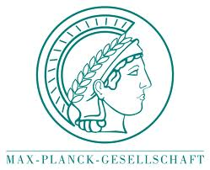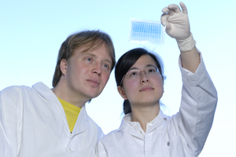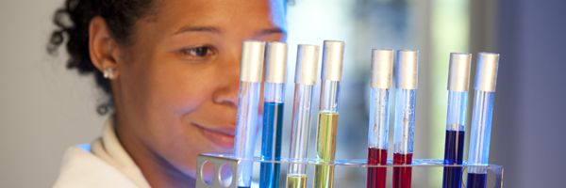
“How do nerve cells communicate with one another? How can complex organisms develop from a single cell? What regulates our "internal clocks"? Scientists at the Max Planck Institute for Biophysical Chemistry are concerned with the molecular processes that drive and regulate the complex processes of life itself. These processes are not easily observed, however. They play out in the cellular nanocosmos and are invisible to the naked eye. Common microscopes allow us to track bacteria and observe individual cells, however they reveal very little about what happens deep in the interior of living cells.”

Shipbuilding
- Hatecke GmbH, Drochtersen
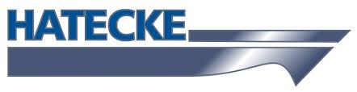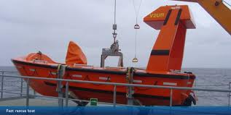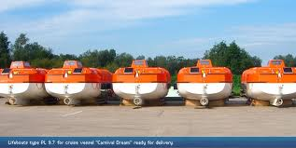
„Hatecke Service GmbH was founded in 2005 when it became clear that new maintenance and service requirements for lifesaving equipment would become mandatory. All after-sales and training activities were combined under one roof, independent of Hatecke GmbH.
On July 1, 2006, SOLAS III, 20.11 came into effect. This new regulation requires the periodic servicing of launching appliances and on-load release gear of lifeboats. The guidelines for this new regulation are laid down in Annex 1 to MSC.1/Circ.1206 dated May 26, 2006.
Hatecke complies with these regulations through its own HATECKE SERVICE Company and a global network of service stations. Together we offer advice and support on an individual basis – flexible service and fast solutions.“

- Fr. Fassmer GmbH & Co. KG, Berne
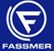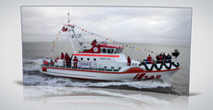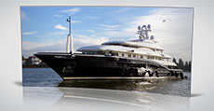
“Fassmer is a dynamic family-owned shipyard in its fifth generation. The internationally successful company is active in six business areas: Shipbuilding, Lifeboats, Deck Equipment, Wind Power, Composite Technology and After-Sales Service. Our clients appreciate the close cooperation with research institutes, innovative in-house design and engineering, modern production facilities and a worldwide service network.
We are one team
Each step within the construction and production process demands maximum performance. This can only be reached with highly qualified employees and regular training sessions. More than 900 people work for Fassmer worldwide, half of them in Germany. Their expert knowledge and motivated attitude to their work reflecting the duties they fulfill represent the company’s great potential! Benefit from other business areas.
Convincing synergy-effects between the six business areas are a great advantage for the company. The client profits from the cumulative expertise!“
- Fr. Lürssen Werft GmbH & Co. KG, Bremen
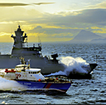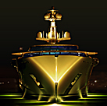
“The Lürssen family has been operating Lürssen Shipyards for four generations and more than 135 years. Today, the company designs and builds ships of the highest quality for demanding customers all over the world.
Lürssen has earned the experience and expertise required to create vessels that meet virtually any set of individual wishes and different demands. The legendary quality of Lürssen stands for satisfied customers and ships that can be completely relied on in any situation.
As a traditional owner-operated company in family hands, Lürssen is fully free of obligation to external stakeholders. Our greatest responsibility is to the quality of our products.
No other shipyard in the international market has developed, built and delivered so many ships to so many countries.
Place your project in our hands, and let us design and build your ships – exactly as you wish them.”

- Abeking & Rasmussen Schiffs- und Yachtwerft AG, Lemwerder
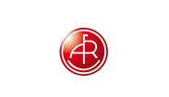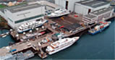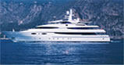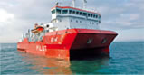
„Along the banks of the river Weser the shipyard Abeking & Rasmussen was founded in 1907. Over the decades, it has evolved into a state-of-the-art shipbuilding complex, currently consisting of 5 halls of ships of lengths up to 80m, modern office buildings, an inner harbour and a syncrolift. Environmentally friendly workshops housing high performance production facilities for conventional steel, aluminium and non-magnetizable steel.
It is unlikely to find a type of ship that is as charged with emotions as a yacht. Whether it is a sailing or a motor yacht, this type of build is always very personal and is often the fulfilment of a lifelong dream. It is our task to create functional and reliable reality based upon that dream without having to compromise aesthetically. No matter where the development starts: in house or in cooperation with a renowned international designer- our heart will always be with it the entire way. And nowhere will one find more variety: a classical wooden sailing yacht, a fast and modern aluminium sloop or the solid steelwork of a motor yacht; every new build is unique and the reflection of its owners’ style and life philosophy.
The shipyard has been developing and building ships for navies, coastguards, the public sector, ship operators and private customers since 1907. In addition to sailing- and motoryachts, current products include minesweepers and –hunters, patrol boats plus special ships like research and supply ships for the offshore industry. “
- Meyer Werft GmbH, Papenburg
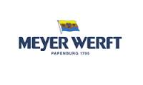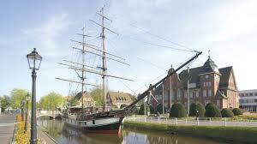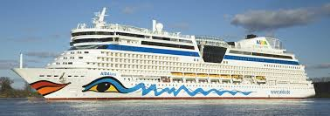
„MEYER WERFT, based in Papenburg, was founded in 1795 and is in its sixth generation of family ownership.
MEYER WERFT has achieved an excellent worldwide reputation over the last decades. The company is especially known due to the construction of huge, modern and sophisticated cruise ships.
MEYER WERFT was the first compact shipyard in Europe and is one of the most modern shipyards in the world. The two covered docks as well as the modern manufacturing plants and the concept of short distances ensure the shipyard’s success. Innovations and the newest technologies characterize the shipyard's daily routine.
Modern computer technology is used everywhere, be that the first layout or the design of the ship or the production process. Construction drawings are hardly found. They are replaced by simulations by which the shell plating of a ship is designed, to name but one example.
Almost the whole production process has been digitized, which saves time and money. A lot of projects can be planned and saved in the virtual world, and assembly processes can be tested. 3-D simulations allow planning with a high degree of anticipation. Production and production process can be developed at the same time: This saves time and effort and leads to a better efficiency.
The "Digital Factory" is extremely helpful in planning and designs because the engineers can estimate at very early stages what can be implemented and what can't. This avoids "surprises" in the production process, and accelerates construction. Mistakes can be avoided well before they cost a lot of money when the ship is already at the production stage.
The computer-aided logistics system minimizes storage space and thus operating costs. The material-flow control system TESS controls the whole material flow on the shipyard via data radio. Each structural component is with the right person at the right place at the right time. Shortest transport routes, minimal empty runs and precise just-in-time-supply are ensured. “

Wind industry
- Enercon GmbH, Geseke

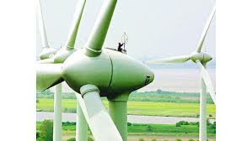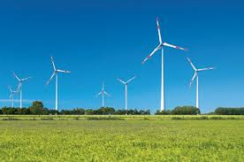
ENERCON began its road to economical / ecological success when graduate engineer Aloys Wobben founded the company in 1984. A small team of engineers developed the first E-15 / 16 wind turbine with a rated power of 55 kW. To start with, ENERCON systems still featured gearboxes. However in 1992, the changeover to gearless technology came about with the first ENERCON E-40 / 500 kW. This innovative drive system with few rotating components ensures nearly friction-free energy flow providing outstanding performance and reliability. Mechanical stress, operating and maintenance costs are reduced, and the system’s service life is increased.
Today, all ENERCON wind energy converters are based on the company’s tried and tested turbine concept. Over the past years, new system generations have evolved through constant sophistication of existing components, providing customers with state-of-the-art products.
Since then ENERCON has been setting new standards in technological design for 30 years now. With more than 22,000 wind turbines installed in over 30 countries, ENERCON is also recognized as one of the leading manufacturers at the international level. Research and development, as well as production and sales are constantly evolving.

- GE Wind Energy GmbH, Salzbergen
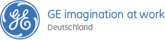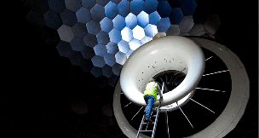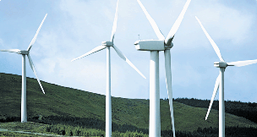

„GE is a global technology, service and financial company with more than 300,000 employees in over 100 countries. It focuses on innovations in the fields of energy, health, transportation and infrastructure.
In Germany GE has been active for over 100 years. The commitment of a firmly-rooted company in Germany has grown, which now includes about 7,000 employees in over 70 locations. Company focuses on energy, medical and financial services. GE invests in renewable energy, innovative medical solutions, efficient aircraft and transportation technologies and supports the investment capacity of industry, SMEs and municipalities with attractive financing offers.“

- NSW Norddeutsche Seekabelwerke GmbH, Nordenham
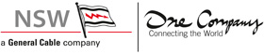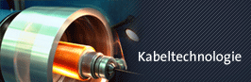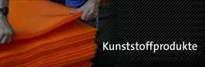
„NSW is a leading manufacturer of communications, submarine, overhead, power and offshore cables as well as engineering plastics and environmental products. For over 100 years, NSW has been committed to the expansion and improvement of communications. The company serves customers all over the world. Every person’s claim to freedom is reflected in the workaday world at NSW in that we are prudent in our dealings with employees and handle our economic and ecological resources with respect. This is how we protect the environment and assure a livable environment for the people working for us, the customers who use our products, our neighbors and the public at large.
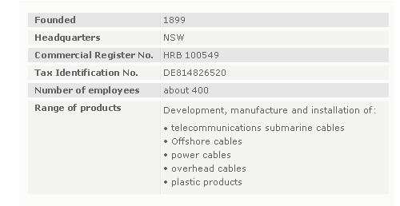“

- Nexans Deutschland GmbH, Hannover
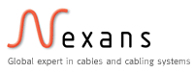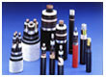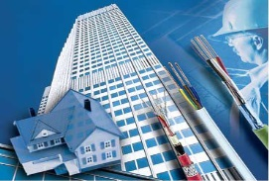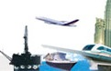
„Infrastructure: Nexans provides complete cables and cabling solutions for power production, transmission and distribution. New technologies significantly increase capacity and reduce the danger of blackouts. To reinforce rail safety and efficiency, we have products especially designed tor the demanding railroad environment.
Industry: Nexans offers a complete portfolio of cables and solutions for market segments as diverse as the automotive, rolling stock and aerospace industries, shipbuilding, nuclear power, oil & gas and petrochemicals, material handling and automation.
Buildings: Nexans supplies cables and network solutions for structures of all types: from small residences to public and office buildings and big industrial complexes.“
Forging Industry
- Buderus Edelstahl Schmiedetechnik GmbH, Wetzlar
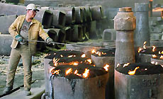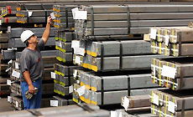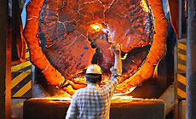
„Buderus Edelstahl GmbH is located in Wetzlar, Germany, and is one of Germany's leading producers of high-grade special steels.
All stages of production, from melting through to the final product, are conducted in-house. This total control is a key factor in our outstanding success in the marketplace. For our valued global clientele it means capability, responsiveness and flexibility in meeting their requirements.
Our company is also noted for its responsive service provision, short throughput times, and its first-rate, transparent scheduling and quality assurance system.
Buderus Edelstahl GmbH is a member of the voestalpine AG.“

- Johann HAY GmbH & Co. KG, Bad Sobernheim
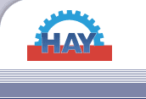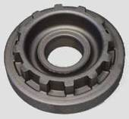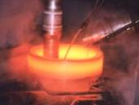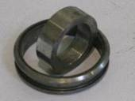

“Basic facts:
- Founded in 1925 by Johann Hay
- About 1300 employees at two plants in Bockenau and Bad Sobernheim – by car approximately 1 hour from Frankfurt/Main
- Supplier of forged and machined components to all German and most European OEM’s for engines, gearboxes (transmissions) and axles
Market position:
- Largest European producer of flywheels outside the OEM’s internal production with 2.0 million flywheels per annum
- Second largest European producer of starter ring gears with 6 million parts per annum
- Largest European producer of hot rolled seamless rings
- Largest European producer of final drive gears and crown wheels for differential gears”

- Stahlwerk Augustfehn Schmiede GmbH & Co. KG, Apen
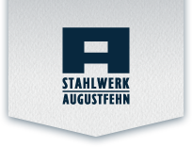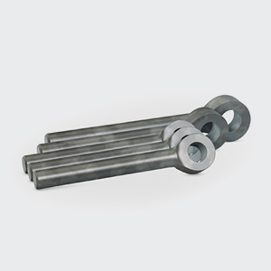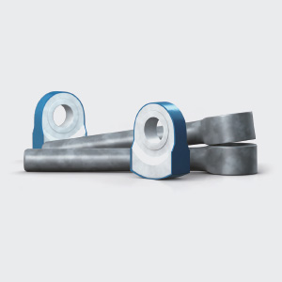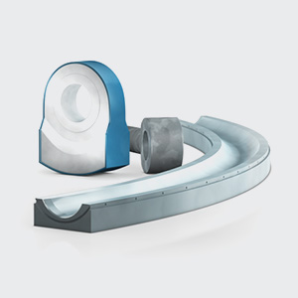
„Stahlwerk Augustfehn has been successful with its products in a number of markets for over 140 years. A key to this success has been the skill, dedication, and enthusiasm of our employees, along with the capability of specialising in and adapting to the respective market conditions. We continue to build on our good relationships with customers and suppliers and, hence, productive market partnerships. Our customers can be sure that we will find made-to-measure solutions for them that meet or exceed the usual standards and to which we have precisely tuned our production. As genuine problem solvers, we deliver ready-to operate products, e. g. shredder hammer and hammer for cement grinding, wear plates and blow bars, hammer pins, slewing bearings and large diameter bearings. In short – we can manufacture ready-to-install tools exactly to drawing using various procedures and adapt them if necessary. Our comprehensive range of services includes close and intensive consultation with the customer to ensure the appropriate choice of materials and, if desired, the construction and design of the necessary components. We are a medium sized independent forging company with the facilities and flexibility to assist virtually any customer in meeting the most demanding objectives. We have an extensive product range and are experienced with a wide range of materials. Our competencies and capacity enable large scale production runs to be delivered within deadline. “

- RASCHE Umformtechnik GmbH, Plettenberg
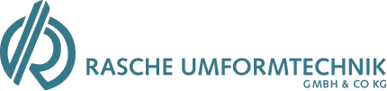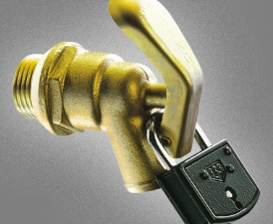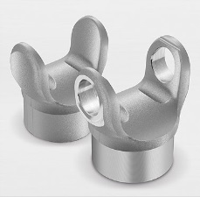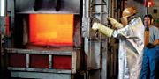
„Quality first since 1925.
With more than 160 employees, we produce over 300 forgings, upset forgings and pressings between 50 g and 10 kg for the most diverse fields of application. Our annual consumption of steel exceeds 15,000 metric tons. Projects are implemented, solutions created and customer wishes put into practice by our in-house development department with the help of cutting-edge technologies. The integrated tool workshop provides ideal conditions for a flexible, reliable and safe production environment.“

